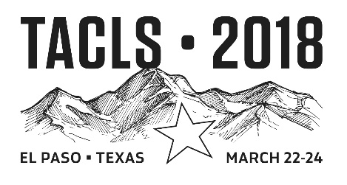
TACLS Scientific Poster Competition Abstract & Application

This application form and accompanying abstract must be received by March 2, 2018.
Please use one form per presentation.
I hereby request that my abstract is considered for poster presentation at 2018 TACLS State Meeting and that it be entered in the Scientific Poster Competition. I understand that participation requires my registration and attendance (Friday, March 23st minimum) and that the associated costs are my responsibility.

Abstract title:

Abstract author (s):

ASCLS member number/numbers (student or professional):

Presenting Author’s Phone:

Presenting Author’s E-mail address:

Education program or Institutional affiliation:

Indicate if submission is:
[ ] Undergraduate Student Scientific Poster
[ ] Graduate Student Scientific Poster
[ ] MLS Professional Scientific Poster

Presenting author’s signature:

Abstract and Submission Form Deadline is March 2, 2018
The abstract must be submitted electronically as an MS Word file, not a PDF, and signed abstract submission form may be scanned and emailed or faxed. Send to

Jacen S Moore, PhD,
FAX: 915.747.8224
Email: jsmaiermoore@utep.edu

